EXPIREMENT - 3

AIM: Linear regression model for forecasting time series data.

PROCEDURE:
- Import Libraries
import matplotlib.pyplot as plt
import numpy as np
import pandas as pd
import seaborn as sns

import os
for dirname, _, filenames in os.walk('/content/AirPassengers.csv'):
for filename in filenames:
print(os.path.join(dirname, filename))

- Load Data
passengers = pd.read_csv('/content/AirPassengers.csv')
passengers.head()
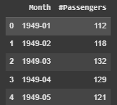
- Data Exploration & Preprocessing
passengers.info()
new_columns = ['Date', 'Passengers']
passengers.columns = new_columns
passengers.head()
- Data Aggregation
groupby_passengers = passengers.groupby(by='Date').sum()
- Visualization
fig, (ax1, ax2) = plt.subplots(1, 2, figsize=(10, 6))
sns.histplot(data=passengers, ax=ax1, legend='')
sns.histplot(data=groupby_passengers, ax=ax2, legend='')
plt.suptitle('Original Distribution | Groupby Distribution')
fig.legend(['Passengers'])
plt.show()
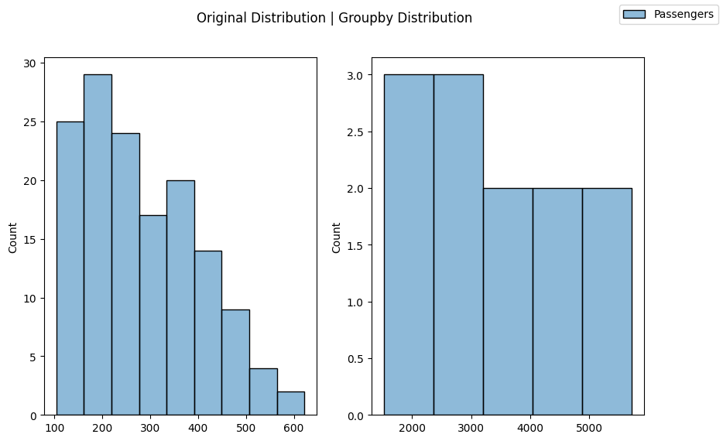
figure, (ax1, ax2) = plt.subplots(1, 2, figsize=(18, 8))
plt.suptitle('Original Distribution | Groupby Distribution')
ax1.plot(passengers['Passengers'])
ax1.set_xlabel('Days')
ax1.set_ylabel('Qtd. Passengers')
ax2.plot(groupby_passengers)
ax2.set_xlabel('Years')
ax2.set_ylabel('Qtd. Passengers')
plt.show()
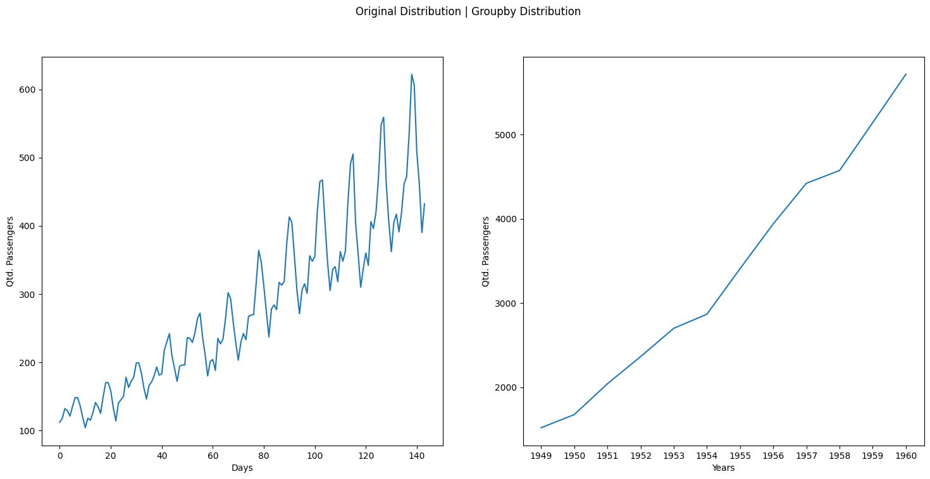
- Linear Regression Implementation (Expected)
from sklearn.linear_model import LinearRegression
from sklearn.metrics import mean_squared_error
x = groupby_passengers.index
x = np.array(x).reshape(-1, 1)

y = groupby_passengers['Passengers']
lm = LinearRegression()
lm.fit(x, y)
predict = lm.predict(x)
plt.scatter(groupby_passengers.index, y)
plt.plot(groupby_passengers.index, predict, color='r')
plt.show()
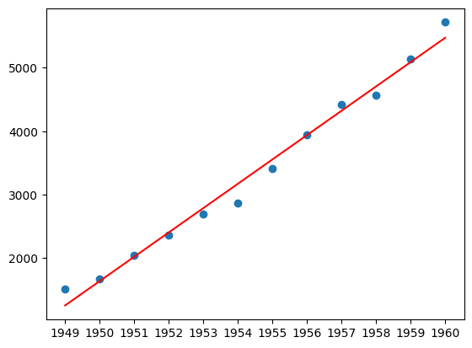
mse = mean_squared_error(y, predict)
rmse = np.sqrt(mse)
rmse

Result
The program to implement a linear regression model for a time series data has been done successfully

